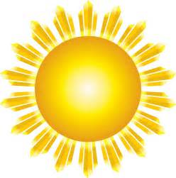
Attention Teens and Tweens:
Join us at the Ada Public Library for
The Sun our Star
Eclipse Preparation
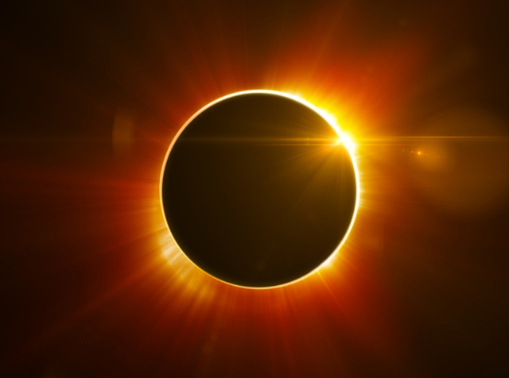
Presented by Dr. Carl Rutledge
Monday, June 19, 2017
At 10:30 a.m.
And 1:30 p.m.

Students ages 8 to 17 are invited to join us as we learn scientific facts about the sun and prepare for the upcoming August 21st eclipse.
View sunspots through the special solar telescope.
Call Debbie at 436-8125 (ext. 287) for more information.
_____________________
Ada Public Library – 124 S. Rennie – Ada, OK 74820 - 580-436-8125

